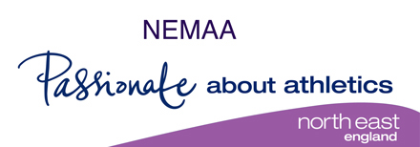
NORTH EAST MASTERS ATHLETIC ASSOCIATION ANNUAL ROAD RELAY WEDNESDAY 01 MAY 2024 at BEDESWELL / CAMPBELL PARK HEBBURN (UNDER UKA RULES) LICENCE NUMBER – 2024 - 46344
The Relay is open to all masters who are UKA registered first claim members of the club for which they are competing (non-NEMAA members are welcome).
The race HQ is at Jarrow & Hebburn AC Clubhouse at Monkton Stadium Jarrow, Tyne & Wear, NE32 5NJ. There will be two races in which teams of three runners, each runner will complete 2 laps each of approximately 1.5km on tarmac paths around Bedeswell Park / Campbell Park. Please park responsibly at or around Monkton Stadium or future use of the venue could be jeopardised. There is a combined limit 450 for the two races.
Race 01 6.30 Women 35 & over, Men over 65
Race 02 7.15 (approx) Men 35 – 64
Awards Race 1 First three teams F35-44 F45-54 F55+ Men 65+ Race 2 First three teams M35-44 M45-54 M55+
Entry fee £15.00 per team of three runners. Clubs may enter more than one team in an age band. Down-aging is permitted in accordance with the BMAF rules, each club must adhere to these rules or risk disqualification. Teams must be declared at least 15 minutes before each race with names and actual ages on the day specified on the official team entry sheet.
We are small organising group that rely on volunteers to run our events. If you are able to help us with the relays please contact Paul Bentley at p.bentley@btinternet.com, you will be given a duty on the day.
Entries close Friday 26 April. No entries on the day .……………………………………………………………………………………………………………………………………………………….

